Instructions for Registration
CITI training through the University of Pennsylvania

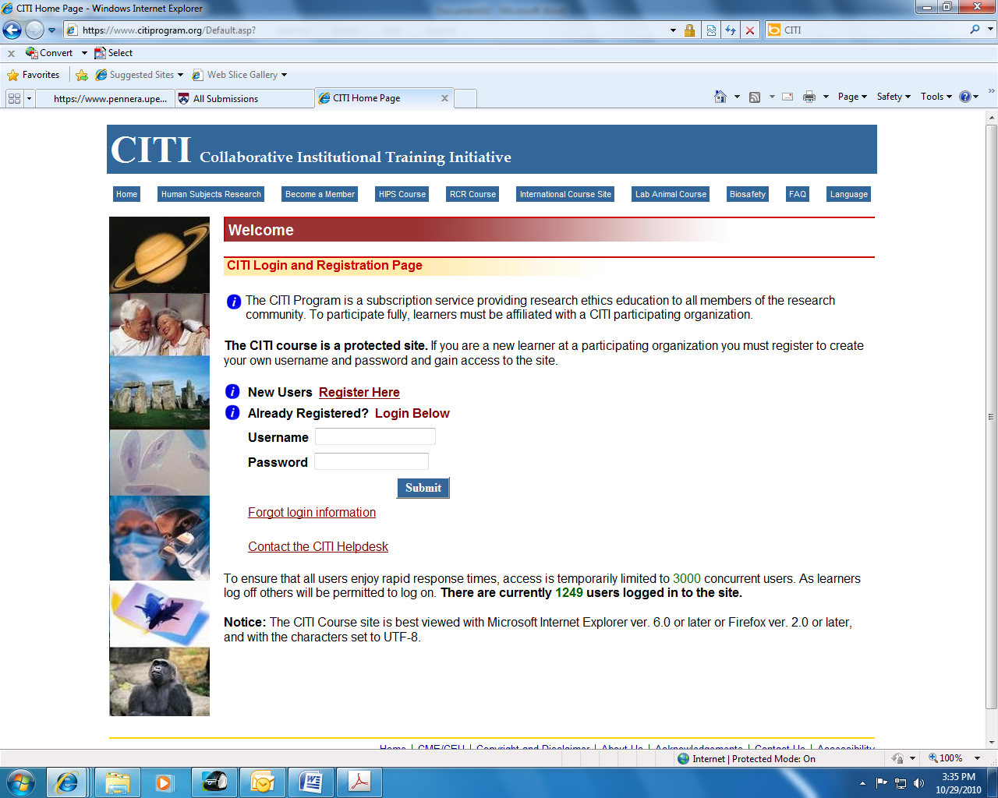
Log onto www.citiprogram.org
Click “Register Here” to Create a New Registration
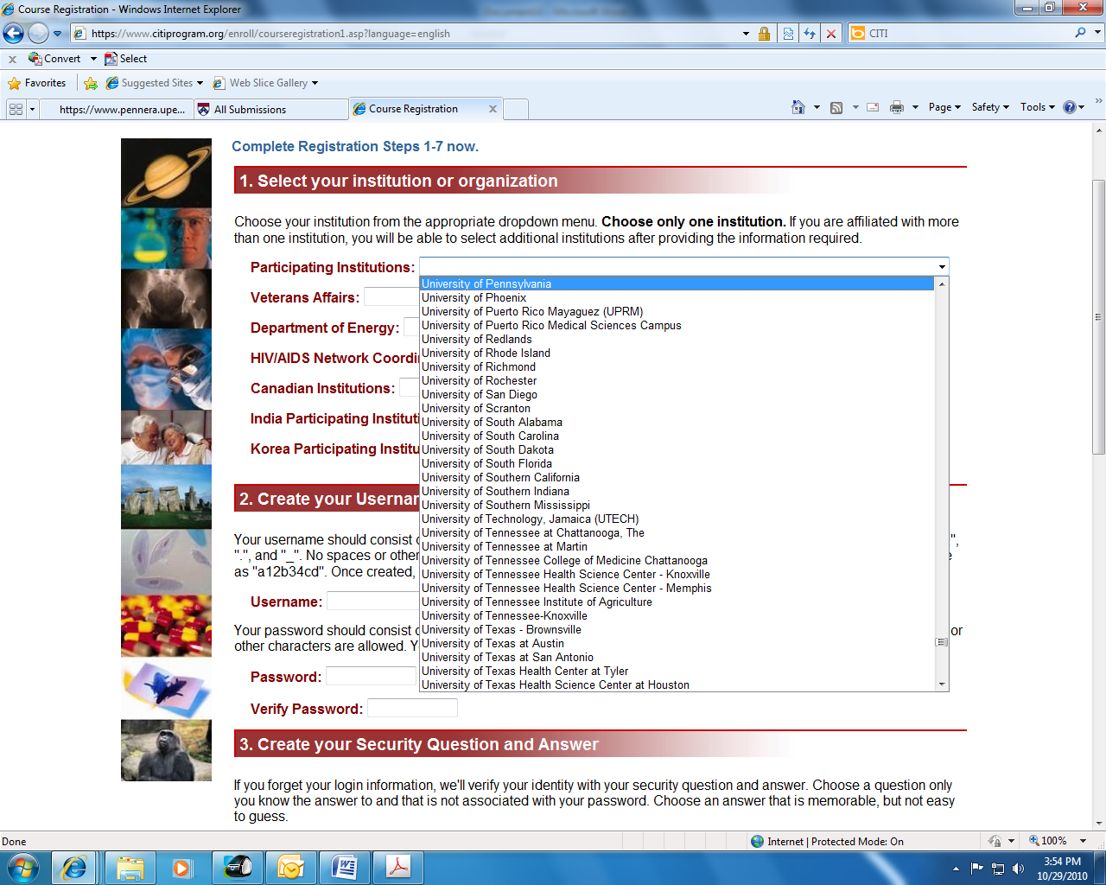

Select the “University of Pennsylvania” as your Participating Institution.
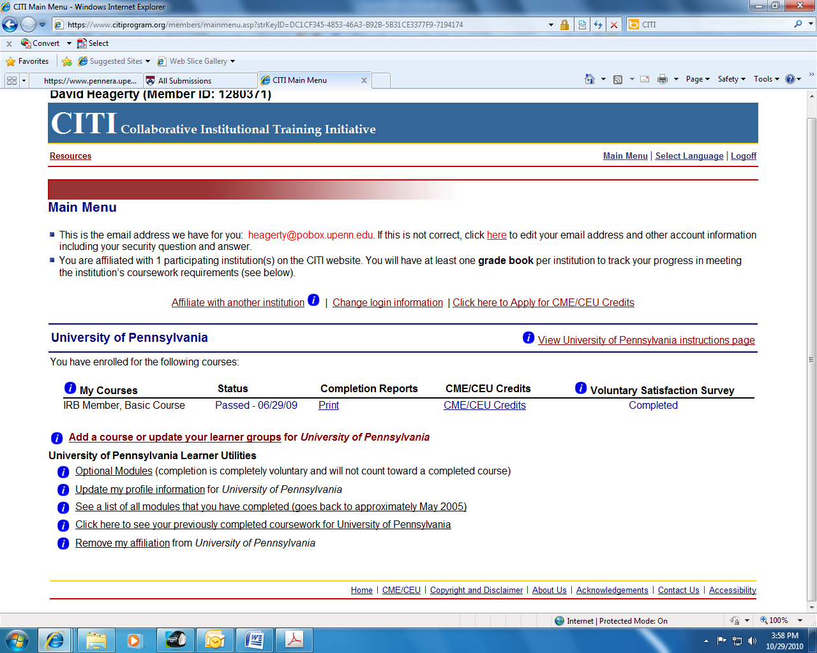

Select “Add a Course or Update your Learner Group”

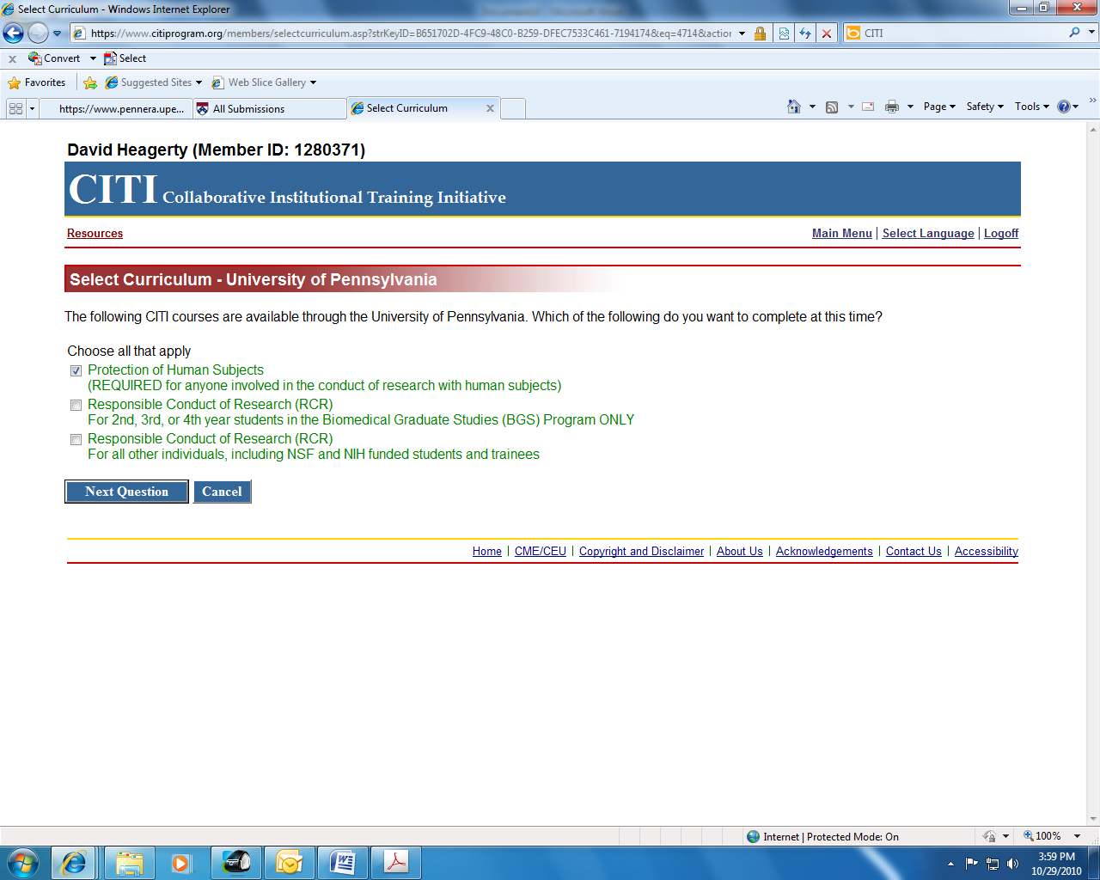

Select Protection of Human Subjects as the Course you wish to Complete
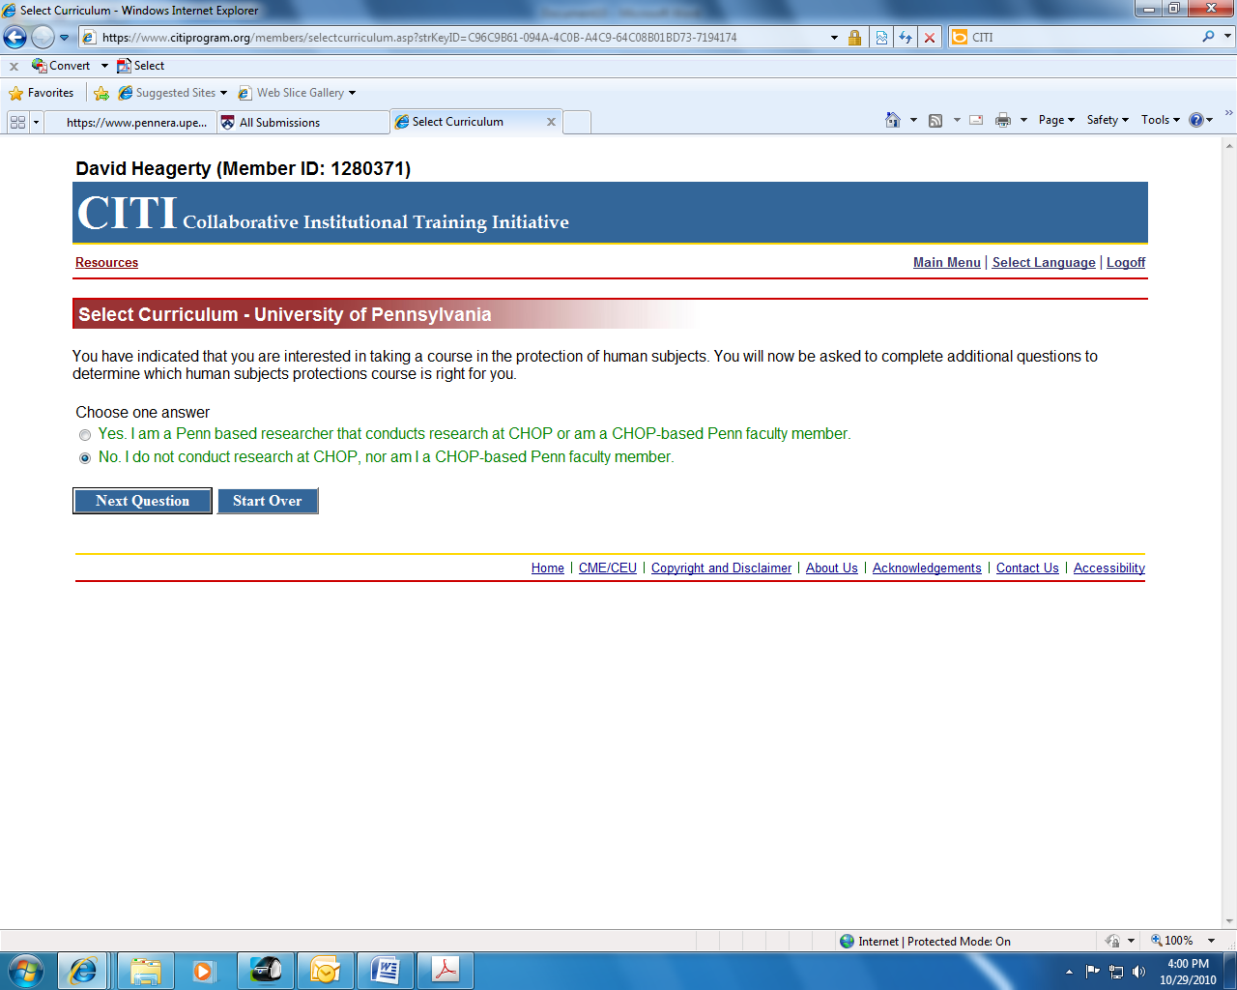

Check “No” to the question asking whether you conduct research at CHOP or are a CHOP-based Penn faculty member. If you do complete research at both Penn/CHOP, please answer yes. Please Note: The only two options for people who choose “Yes” to this question are a full Biomedical Course or a Biomedical Refresher Course.

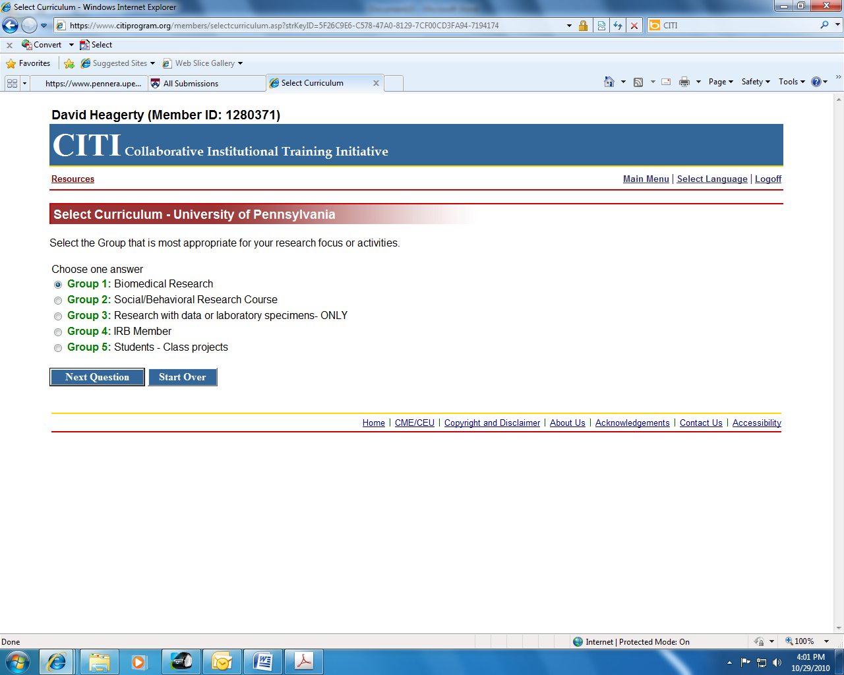
Select the appropriate group that applies to the type of research you are involved with. Select “Group 1” – Biomedical Research if you conduct Biomedical Research.

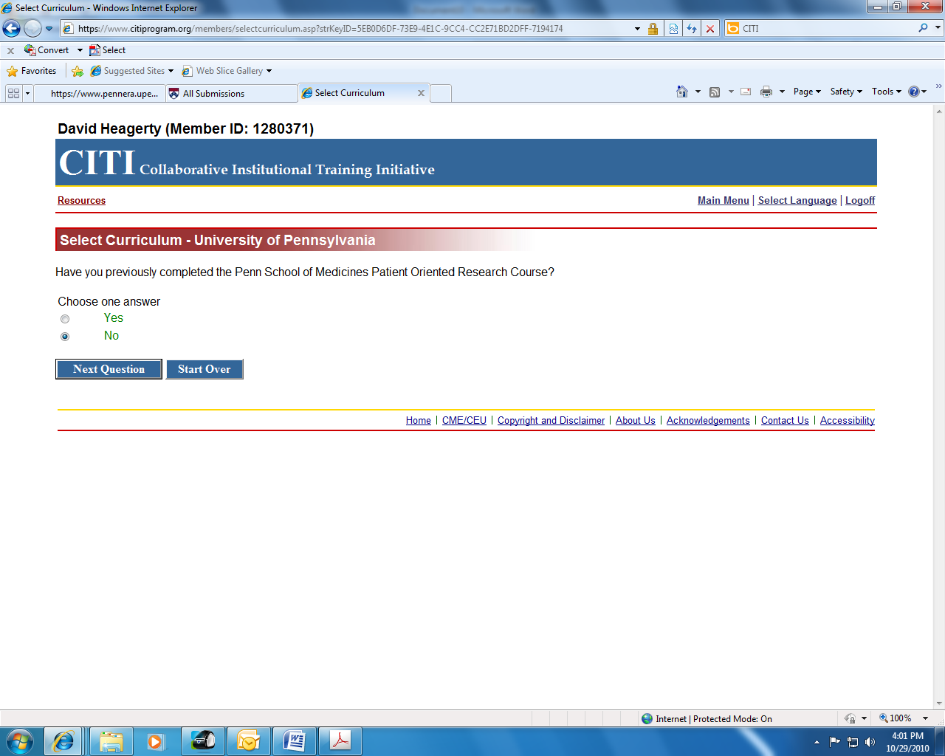

Select “Yes” to indicate that you have previously completed Penn’s POR training if you have completed it in the past and now only wish to take the Refresher course.
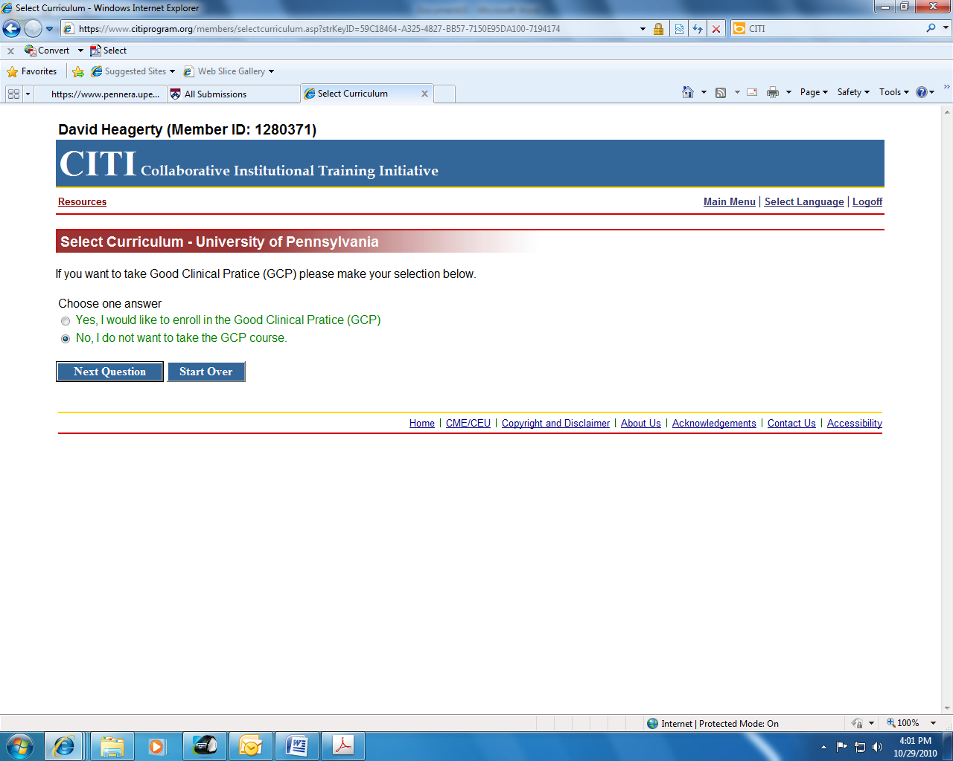

Select “No” to indicate that you do not wish to complete the GCP course.
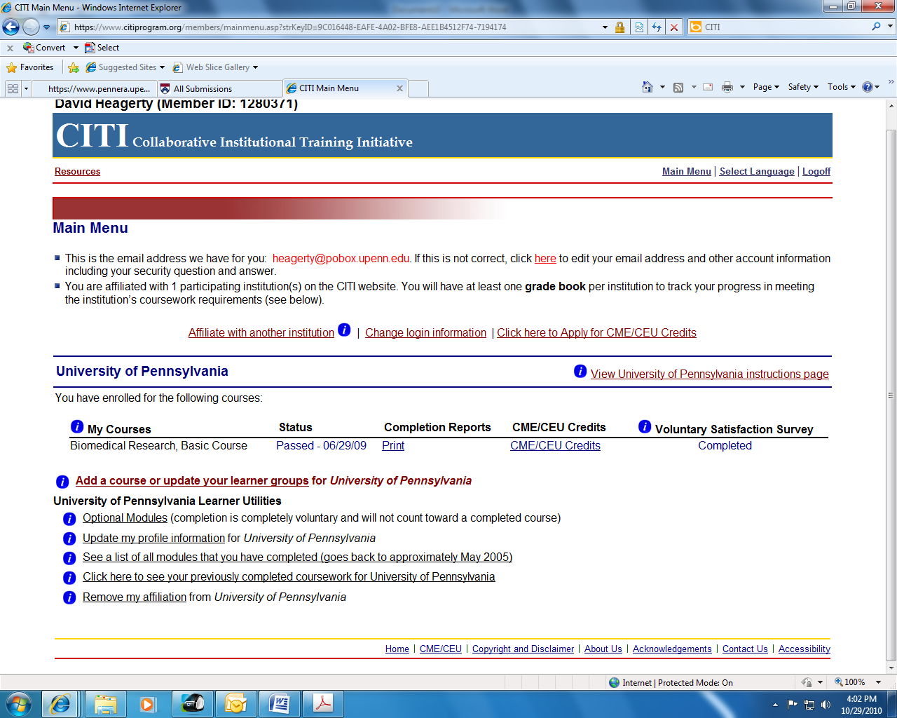

The course will appear under “My courses”. There will be a button next to the course that lists “enroll” please click that button. In this case the learner already completed the course so it reads “passed”. The learner in this case marked “No” to the question asking whether they completed POR in the past so they were assigned the full course. If they had marked “Yes”, the Refresher course would have appeared in the course assignments.

